7.1.26 Editors - 3D View - Header - Text - Edit mode - Text menu
Inhaltsverzeichnis
Edit Mode - Text Menu 2
Cut 2
Copy 2
Paste 2
Paste File 2
To Uppercase 2
To Lowercase 2
Last Operator Set Case 2
Insert Unicode 2
Special Characters 3
Move Cursor 3
Toggle Bold 3
Toggle Italic 3
Toggle Underline 3
Toggle Small Caps 3
Kerning 4
Decrease Kerning 4
Increase Kerning 4
Reset Kerning 4
Last Operator Change Spacing 4
Delta 4
Delete 4

Edit Mode - Text Menu

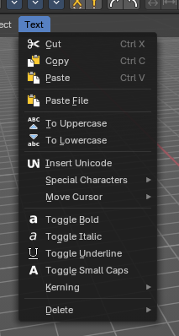
Cut
Cuts the selection.

Copy
Copies the selection.

Paste
Pastes a copied selection.

Paste File
Opens the file browser where you can choose a text file to paste the text from. It needs to be UTF8.

To Uppercase
Sets the selected text to be uppercase letters.

To Lowercase
Sets the selected text to be uppercase letters.

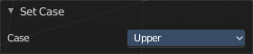
Last Operator Set Case
Set Case has one Last Operator for all items.

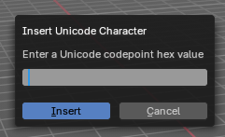
Insert Unicode
Inserts a Unicode character. When you use the operator, a dialogue box will prompt you to enter a Unicode codepoint hex value to insert the character.

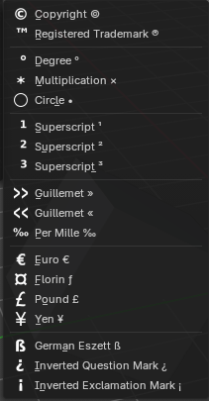
Special Characters
Special characters is a sub menu that contains some special text characters, like copyright, which you can insert into the text.
- Copyright ©
- Registered Trademark ™
- Degree °
- Multiplication ×
- Circle ○
- Superscript ¹
- Superscript ²
- Superscript ³
- Guillemet Left «
- Guillemet Right »»
- Per Mile ‰
- Euro €
- Florin
- Pound £
- Yen ¥
- German Eszett
- Inverted Question Mark ¿
- Inverted Exclamation Mark ¡

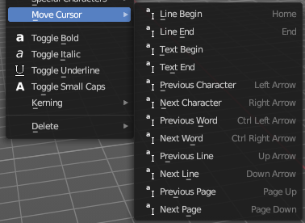
Move Cursor
Set the cursor at specific positions in the text.

Toggle Bold
Bold sets the selected letters to be displayed as bold letters.

Toggle Italic
Italic sets the selected letters to be displayed as italic letters.

Toggle Underline
Underline sets the selected letters to be displayed as underlined letters.

Toggle Small Caps
Toggle small caps sets the selected letters to be displayed as if they were upper case letters, but with lower case size.

Kerning
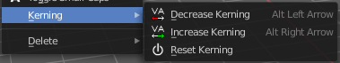
Kerning is the distance between letters. Increase, decrease and reset the kerning.

Decrease Kerning
Decreases the distance between the letters.

Increase Kerning
Increases the distance between the letters.

Reset Kerning
Resets the distance between the letters to the default values from the font.

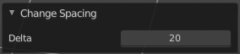
Last Operator Change Spacing

Delta
Adjust the spacing. The range goes from -20 to 20.

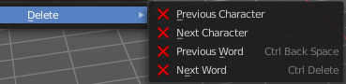
Delete
Deletes the selected text.

